CSA1708-ARTIFICIAL INTELLIGENCE
LAB EXPERIMENTS
Program 6 : Python Program for Vacuum Cleaner Problem
Aim
To develop a Python program to simulate the Vacuum Cleaner Problem using an intelligent reflex agent to clean all dirt in a multi-room environment.
Algorithm
1. Define the environment model consisting of two locations: Location 'A' and Location 'B'.
2. Represent the state of each location as either 'Dirty' or 'Clean'.
3. Initialize the vacuum agent at a starting location (e.g., Location 'A') with predefined cleanliness statuses.
4. Sense the current percept: perceive the agent's current location and whether that room is 'Dirty' or 'Clean'.
5. Apply the reflex condition-action rules:
6. a. If the current location is 'Dirty', trigger the 'SUCK' action to clean the room and change its status to 'Clean'.
7. b. If the current location is 'Clean':
8. - If currently at Location 'A', execute action 'MOVE' to Location 'B'.
9. - If currently at Location 'B', execute action 'MOVE' to Location 'A'.
10. Track performance cost (number of actions executed) and repeat the percept-action cycle.
11. Terminate when all locations in the environment are confirmed to be 'Clean'.
12. Display the detailed action sequence and the final clean state.

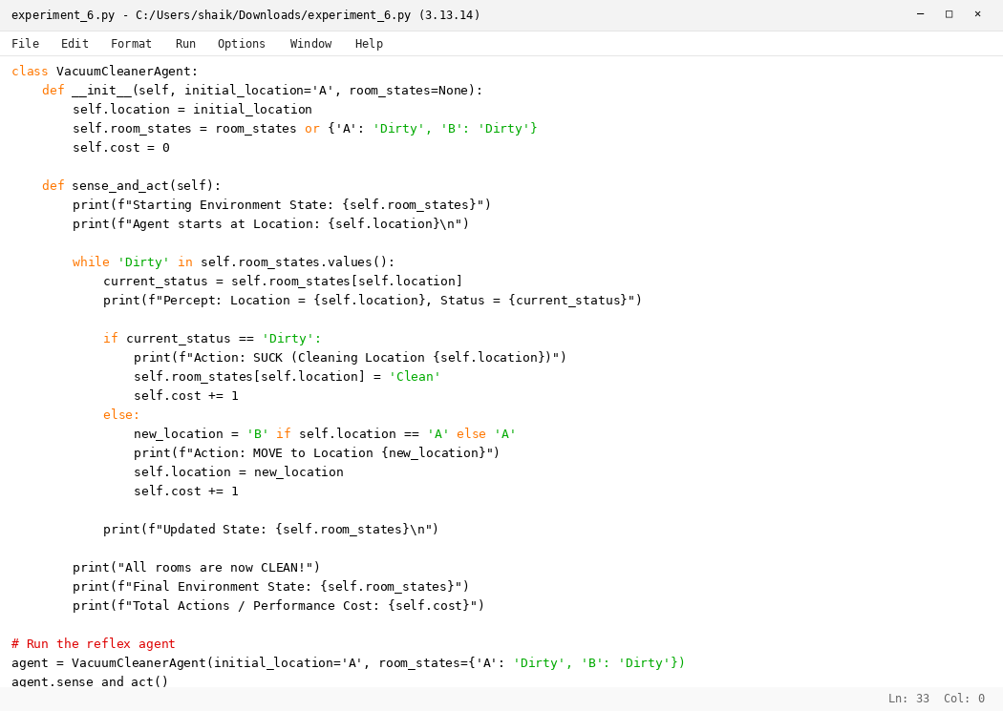

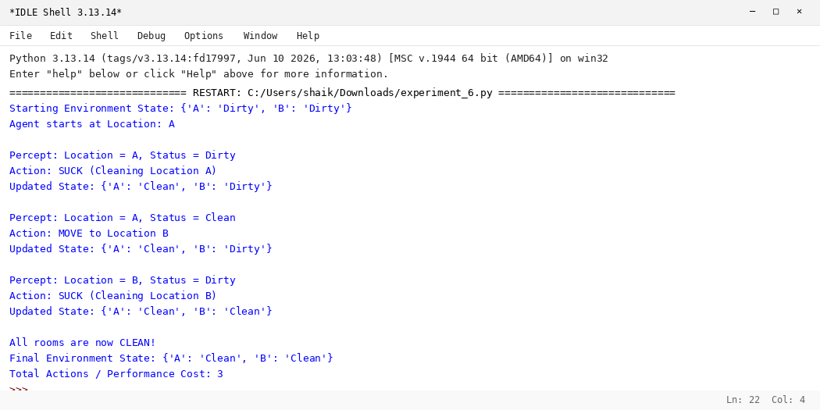

RESULT
Thus, the Vacuum Cleaner Problem was solved successfully using Python.

